Referring Doctor

Functionality: These are a series of screens grouped together that offer information about and related to a given person. Within these screens, the user can edit, add or remove related information. The information is divided into two, Summary and Associate. There is also a Profile line, which gives basic information about the person. This line appears on each screen but is only editable from the Summary Page.
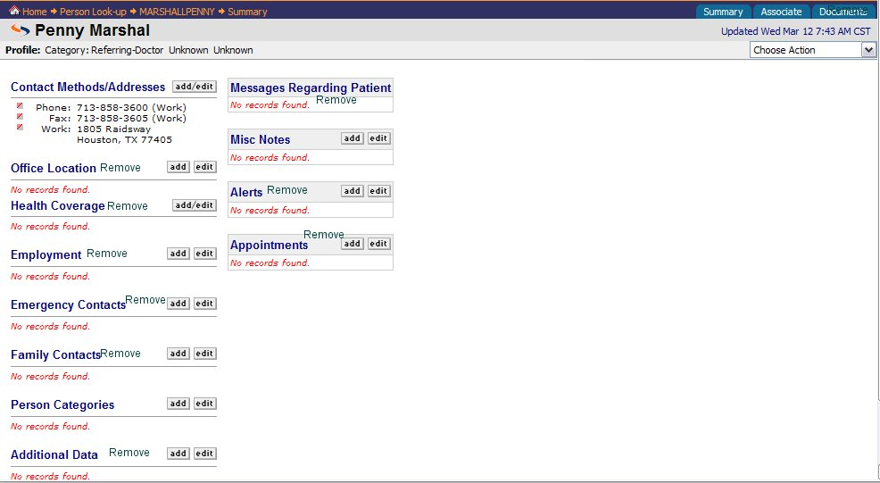

Profile Line:
The profile line allows the user to view basic information about the person at all times when they are in the person’s page. However, it is only editable from the Summary Page. Originally, the information obtained for the profile line comes from information added at Add-a-Referring Doctor. If the user needs to edit information on this line, they should be able to do so from the Summary Page. Currently, on Physia, there is a Choose action box drop. The only item needed in that box is Edit Profile. Once the user chooses to edit profile→application takes user to Edit Profile dialogue. → User makes changes→User clicks [OK] to save changes→application acknowledges update→application takes user back to Summary Page for Person.

Summary Page:

This tab consists of basic information that is directly related to the person. On this page the user should be able to view/add/edit the following Categories: Contact Methods/addresses, Person Categories and Misc Notes. The users can add/edit information on this screen. The screen in Physia handles the majority of this but the following Changes should be made:
Remove:
Office Location Health coverage
Employment Emergency Contacts
Family contacts Additional Data
Messages Regarding Patients Alerts
Appointments

Category: Contact Methods/Addresses Priority 5
This category includes all contact information for Org.

Add/Edit Function

Functionality: The user has the ability to add or edit any entry from the summary page and other tabs within the Org. The add/edit function should function the same for each category on the summary page.

Add:
The user is able to add new information to a sub category by clicking the ADD/Edit button near the category. In Physia, it is a Hyperlink on the word Add/Edit. If the user does not see the information in the sub category and wishes to add it, then they click the hyperlink→application takes user to add/edit dialogue→
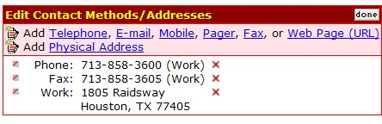
The user clicks the item to add. (In this example it is Telephone) →Application takes user to dialogue for add telephone→
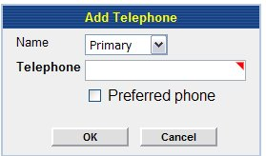
The user has the ability to choose which type of phone number they want to enter. This is in the form of a drop down box. 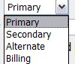. User enters required information
(Again marked with a required field indicator) →User clicks [OK]→application shows new information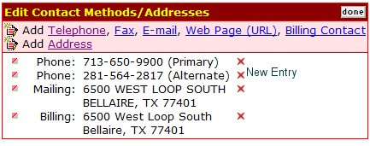

The user clicks [done]→ application takes user back to summary page.

If the user chooses to edit an existing item, at this point, they may choose the to the left of the item and the following dialogue on using the will begin.

Edit: The user can edit from a couple of ways. They can do the short cut and use the edit button in front of the existing item they wish to edit. (In Physia this is the .) Or the user can click the add/edit button on the category box. .

Takes the user directly to the edit dialogue for the item chosen. For example if the user chooses to edit the mailing address the following screen is displayed.

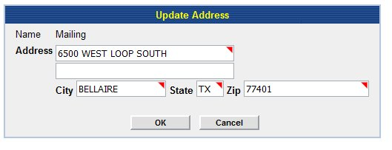
All the information is auto filled. The user simply uses the mouse to move the cursor to the correct box and enters the new information.→User clicks [OK]→application takes user to a screen that displays the edited information and a notification that update is complete:
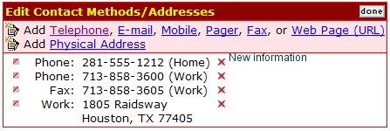

User clicks [done] →Application takes user back to Summary Page.
If user clicks in front of another entry→application takes user to edit dialogue for the chosen item→application continues loop until user clicks [done].

The application should follow the same line of actions for each item in a category. Any differences will be noted within the category below.
This is generally used for adding new items but the user is taken to the add/edit dialogue and has to click the icon in order to edit a field. Once they click the , the user is taken through the actions described above for the . This is a longer process but since the Add dialogue takes you to the same screen and a user can edit an existing item when there, it makes since to keep it. However, the user will be trained in the most efficient way to edit an item.

Person Categories Not a priority 5

The person category should list all categories that a person is typed. The summary page with the most information should be the summary page should be displayed. In order they are Physician, Patient, Staff Member, Nurse, Insured Persons, Referring Doctors, Guarantors.
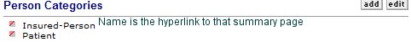
Add
If the user wants to add a category
The user clicks the add button→Application takes user to Add Dialogue choices
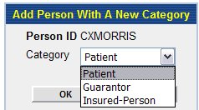

User makes choice and clicks ok→application takes user to Add Dialogue for that category and auto fills the existing information→User enters at least any additional required information (marked with required markings)→clicks [OK] to save→application acknowledges add→ application takes user to summary page of initial viewing. In this case, the Referring doctor summary page.

Edit: Not a priority 5
The user can edit a category by clicking the to the left of the category. The summary page for that category will display to make changes.

Misc Notes Not a Priority 5
This is not a priority five and will be discussed in later documentation. A user can add any free text notes here pertaining to the person.

Associate Tab:

This tab contains all certifications known for the referring doctor. The user can add/edit/terminate the certifications from this tab.
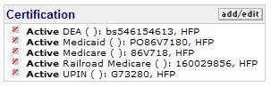

Add:
To add a certification the user clicks the add button→application takes user to add choices→ 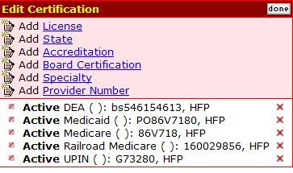 User chooses what they want to add→application takes user to Add dialogue for item chosen→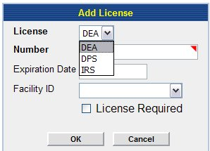→ user adds at least the required information and clicks [OK]→application acknowledges change and takes user back to add/edit information.

Edit:
A user can edit information by clicking the to the left of the information. When the user clicks that box→application takes user to that information and user can update it →user clicks [OK] to save→application acknowledges change and takes user back to summary page for person.

